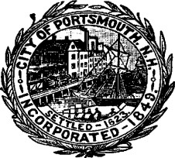

**CITY OF PORTSMOUTH, NEW HAMPSHIRE**

**ECONOMIC DEVELOPMENT COMMISSION (EDC) MEETING AGENDA August 2, 2024 7:30 AM – 8:45 AM**

**In-person Meeting**

**Pease Int’l Airport Lobby**

**36 Airline Drive, Portsmouth, NH**

**AGENDA**

Welcome - EDC Chair

Approval of draft meeting minutes of July 3, 2024

Economic Development Office Update – S. Clancy

Chamber Collaborative Update – B. VanCamp

City Council Update – Councilor Lombardi/Assistant Mayor Kelley

Pease Development Authority – Susan Anzalone / Chase Congreves

* Presentation – Updates and Initiatives
* Questions and Answer session

Public Comment

Next Meeting – September 6th

Adjourn